 | COEP Technological University, Pune  A Unitary Public University of Government of Maharashtra  Department of Applied Sciences & Humanities  (School of Transdisciplinary Sciences & Management)  Wellesley Road, Chhatrapati Shivajinagar, Pune - 411005. | 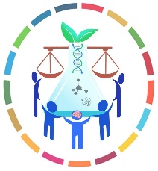

Biology for Engineers
UNIT 1: Cross talk of Biology and Engineering

a) Biologically inspired technologies: Case studies of designs in nature and inspired technologies, Biomemetics: Nature inspired material and mechanisms, Self-healing Bioconcrete, Biomining, Algorithms in nature,
b) Contribution of engineering in biological domain: Contribution of Microscope, Imaging techniques, Bio-medical Instruments, Mechanisms (Ergonomics)

The efforts of engineers are all around us. Take a stroll down the street and we will spot one feat of engineering after another. But what we cannot see are all the feats of engineering people are carrying around inside their bodies. Because engineering is not just about what is around us; it is also about what is inside us. But to understand all these, there should be scope of a cross talk between BIOLOGY and ENGINEERING domain. These are compartmentalized in the traditional/conventional education system.

BIOLOGICALLY INSPIRED TECHNOLOGIES
DESIGNS IN NATURE
Biomemetics: NATURE INSPIRED MATERIAL AND PROCESSES
SELF HEALING BIOCONCRETE
BIOMINING

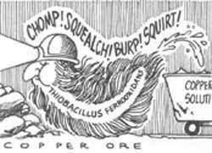
One of the smallest representatives of life forms, BACTERIA, can be seen as a mixed blessing. They cause diseases to plants and animals even to human beings such as tuberculosis and leprosy on one side and they also convert milk into curd. In last couple of decades, we have identified bacteria as miners. These diminutive diggers have become assets to the mining industry eliminating traditional offensive methods which use explosives, toxic chemicals, and high temperatures (Science, Vol 264, No 5160). They also offer economical alternative especially in extracting minerals from low-grade ores on the background of depleting high-grade reserves. Biomining contributes in improving the recovery rates of minerals reducing capital and operating costs.
History: The first miners to exploit microbes, albeit unknowingly, were probably the Romans who worked the Rio Tinto copper mine in Spain 2,000 years ago. They noticed that the fluid running off the mine tailings was blue, an indication that it contained copper salts, from which they then recovered the valuable metal. However, not until 40 years ago did it become clear that the copper in the fluid was in fact the handiwork of a bacterium named Thiobacillus ferrooxidans. The tiny miner has proved to be a godsend for the copper mining industry, which has been left with the low-grade ores that need to be smelted more to produce the same amount of copper. With each new smelter costing $1 billion, the world is running short of smelters. T ferrooxidans, however, can chew up the poor-quality ore which has been treated with sulphuric acid, releasing the copper that is collected in a solution at lower costs. Today, at least 25 per cent of all copper produced worldwide, worth more than $1 billion annually, is extracted using this bug. Of late, biomining has struck gold, too. With depleting high-grade reserves of gold, not only are these microbes cheaper to use than conventional energy-intensive techniques, they also increase the rate of gold recovery from 70 to 95 per cent.
Phosphates have traditionally been extracted from ores either by burning them at high temperatures to yield solid phosphorus or by treating them with sulphuric acid to produce phosphoric acid. But last year, Alan Goldstein of California State University in Los Angeles and Robert Rogers of the Idaho National Engineering Laboratory in Idaho Falls evolved a pair of bacterial strains, Pseudomonas cepacia E-37 and Erwinia herbicola, which can remove the phosphate from the ore at room temperatures, without using corrosive sulphuric acid.
Scientists are now trying to genetically engineer new bacterial strains that can stand up to toxic metals such as mercury and cadmium. However, genetically engineered microbes may take some time to materialise because scientists still know little about Thiobacillus and other bacteria used in biomining.
Source: https://www.downtoearth.org.in/news/biomining-and-bacteria-32220

Biomining is the process of using microorganisms (microbes) to extract metals of economic interest from rock ores or mine waste. Biomining techniques may also be used to clean up sites that have been polluted with metals. Valuable metals are commonly bound up in solid minerals. Some microbes can oxidize those metals, allowing them to dissolve in water. This is the basic process behind most biomining, which is used for metals that can be more easily recovered when dissolved than from solid rocks. A different biomining technique, for metals which are not dissolved by the microbes, uses microbes to break down the surrounding minerals, making it easier to recover the metal of interest directly from the remaining rock.

What metals are currently biomined? - Most current biomining operations target valuable metals like copper, uranium, nickel, and gold that are commonly found in sulfidic (sulfur-bearing) minerals. Microbes are especially good at oxidizing sulfidic minerals, converting metals like iron and copper into forms that can dissolve more easily. Other metals, like gold, are not directly dissolved by this microbial process, but are made more accessible to traditional mining techniques because the minerals surrounding these metals are dissolved and removed by microbial processes. When the metal of interest is directly dissolved, the biomining process is called “bioleaching,” and when the metal of interest is made more accessible or “enriched” in the material left behind, it is called “biooxidation.” Both processes involve microbial reactions that can happen anywhere the microbes, rocks, and necessary nutrients, like oxygen, occur together.

Approaches to bioleaching: Direct v. Indirect Bioleaching
- Direct bioleaching uses minerals that are easily receptive to oxidation to create a direct enzymatic strike using the microorganisms to separate the metal and the ore.
- In indirect bioleaching, microorganisms are not in direct contact with minerals during the process. However, leaching agents are created by microbes, which still oxidise the ore.

What processes are used to biomine? - The most common processes used in biomining are:
- Heap leaching: freshly mined material is moved directly into heaps that are then bioleached.
- Slope/Dump leaching: low-value ore or waste rock is placed in a sealed pit and then bioleached to remove more of the valuable metals from the waste pile.
- Agitated leaching: crushed rocks are placed into a large vat that is shaken to distribute the microbes and material evenly and speed up the bioleaching process.
Leaching times vary from days to months, making this process slower than conventional mineral extraction techniques. Dump and heap leaching are the oldest and most established biomining techniques, but the use of agitated leaching is becoming more common for minerals that are resistant to leaching, including some copper sulfides like chalcopyrite.

Some advantages of bioleaching include:
- Bioleaching can stabilise sulphate toxins from the mine without causing harm to the environment.
- Poisonous sulfur dioxide emissions harm the environment and can cause health problems for miners, and bioleaching avoids this process entirely.
- Bioleaching is more cost-effective than smelting processes.
- Some Bioleaching offers a different way to extract valuable metals from low-grade ores that have already been processed.

What are the environmental risks of biomining? - Most current biomining operations use naturally occurring microbial communities. Because these types of organisms are already common in the environment, the risks from the release of the microbes themselves into the local environment are relatively small. The greatest environmental risks are related to leakage and treatment of the acidic, metal-rich solution created by the microbes, which is similar to the acid mine drainage from some abandoned mines. This risk can be managed by ensuring that biomining is conducted under controlled conditions with proper sealing and waste management protocols.

How common is biomining? - Biomining is currently a small part of the overall mining industry. It is used most frequently when the percentage of the desired metal in a rock is small, or to extract remaining metals from waste rock after conventional mining. In Chile, which currently produces one-third of the world’s copper, many of the most copper-rich ores have already been mined. As a result, biomining is increasingly being used to mine deposits with low percentages of copper, and worldwide, 10-15% of copper is extracted using bioleaching. Biomining is also important in the gold industry, where roughly 5% of global gold is produced using biooxidation. As metal-rich ores are depleted worldwide, and with advances in microbial research and engineering, biomining may become more common in the future.

Other uses of biomining
- New biomining techniques that do not involve oxidation are being tested, which would enable large-scale biomining for different types of minerals and metals.
- Some researchers and companies are testing the use of biomining for recycling, to recover valuable elements from wastewater and electronic waste.
- Several smaller operations recover metals from existing acid mine drainage. These operations recover economically valuable metals that would otherwise cause pollution.
- In Europe, the BIOMOre project is studying the feasibility of biomining deep underground to avoid having to excavate the rocks themselves.

BIOLOGICAL ALGORITHMS

CONTRIBUTION OF ENGINEERING IN BIOLOGICAL DOMAIN

MICROSCOPE
Microscopes have opened up many doors in science. By using Microscopes scientists, researchers and students were able to discover the existence of microorganisms, study the structure of cells and see the smallest parts of plants, animals and fungi. When it comes to biology, Microscopes are important because biology mainly deals with the study of cells (and their contents), genes and all organisms. Some organisms are so small that they can only be seen by using magnifications of 40x-1000x, which can only be achieved with the use of a microscope. Cells are too small to be seen with the naked eye.

Microscopes are not just used to observe cells and their structure but are also used in many industries. For example, electron microscopes help create and observe extremely tiny electrical circuits found on Silicon microchips. Scanning microscopes are much more sophisticated and they have higher magnifications than light-refracting microscopes.

Apart from biological research use and industrial use, Microscopes are also used in the field of genetics. Genetics is the study of variations in an organism generation after generation. Genetic engineering requires the mixing of genes. Genes are even smaller than cells, which is why microscopes are essential in this field.

Microscopes are also used to diagnose illness in hospitals and clinics all over the world. Microscopes magnify the blood samples, so the doctors or the pathologist can see the viruses and the parasites attacking the red blood cells and take the necessary steps to cure it. Without the microscope, mankind would not have been so developed and many diseases would still have no cure.

Microscopic examination confirms the laboratory tests that may be positive for the disease. Technicians count the number of red blood cells infected with the virus or parasite to give the doctors an idea of how advanced the disease is in a patient.

Microscopes use the simple visible light refracting lenses. Electrons, x-rays and infrared rays Scanning electron microscopes are able to resolve the viruses which are far smaller than any cell. They enlarge the view of tiny viruses, which allows scientists to develop the vaccines and cures for infectious diseases in the humans and the animals.

Scanning electron microscopes have magnifications up to several million times to view the molecules, the viruses and the nano-particles. They use the corrective software to increase the magnification and the resolution of images. The computers help the nano-technologists use high-powered electron microscopes to view the objects.

Electron microscopes help prepare the small surfaces for sectioning into small slices. Microscopes enlarge the images of silicon chips to help the engineers create more efficient electronic devices. When more circuits are fitted onto a small chip, the computational power of silicon microchips increases.

All branches of biology use Microscopes especially in Molecular Biology and Histology (the study of cells). Microscopes are the backbone of studying biology. The biologists use them to view the details that cannot be seen by the naked eye such as the small parasites and small organisms which is important for the disease control research.

Source: https://www.magnusopto.com/blog/post/important-of-microscope-in-our-daily-life.html#:~:text=By%20using%20Microscopes%20scientists%2C%20researchers,of%20plants%2C%20animals%20and%20fungi

ERGONOMICS
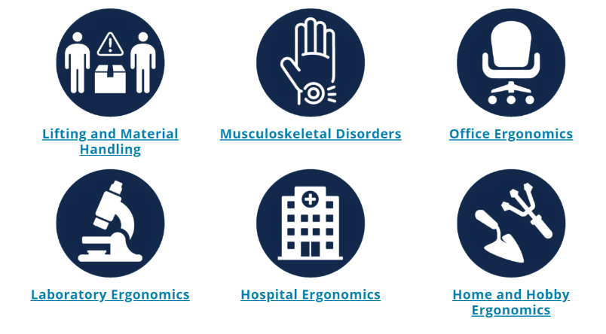
Ergonomics can roughly be defined as the study of people in their working environment. More specifically, an ergonomist (pronounced like economist) designs or modifies the work to fit the worker, not the other way around. The goal is to eliminate discomfort and risk of injury due to work. In other words, the employee is our first priority in analyzing a workstation.

“Ergonomics (or human factors) is the scientific discipline concerned with the understanding of the interactions among human and other elements of a system, and the profession that applies theory, principles, data and methods to design in order to optimize human well-being and overall system performance.”
Source: International Ergonomics Association Executive Council, August 2000

When evaluating a job, looking for three main characteristics known as ergonomic stressors: the force required to complete a task, any awkward or static working postures adopted in completing a task, and the repetitiveness of a task. Any of these factors, or any combination of these factors, may place someone at greater risk for discomfort.

Unit II: Organization of Living Machines
Biomolecules and manufacturing of Biopolymers:
- Carbohydrates (structure-based function and engineering applications)
- Lipids (structure-based function and engineering applications)
- Proteins (structure-based function and engineering applications)
- Nucleic Acids (structure-based function and engineering)
Organization of life forms: Cell to organism
Energy dynamics in biological system

Unit III: Analogy of biological organ/system and engineering device/mechanism

Organ & System: Brain & CPU, Eye & Camera, Kidney & Filtration system, Lungs & purification system, Heart & Pumping system
Process: Photosynthesis & solar cells, xylem & plumbing, thermoregulation in human body & heat transfer in machine, Defense mechanism in organism, Electrical signaling in biology

EYE and CAMERA

Human eye is one of the most powerful and sophisticated sense organs. It assists in viewing objects as well as enables us to perceive light, color, and depth. In terms of its functioning, it is comparable to cameras. Cameras help humans see things when light from outside enters them. The structure and operation of the human eye also aid in our comprehension of how a camera works. Our eyes can gaze around and adjust dynamically based on the environment. Hence, we might think there is no difference between the human eye and a camera. The camera sees whatever the eyes can see, so how exactly are they different from each other? Things, however, are not as simple as they seem; they are way more complicated.

Human Eye: A human eye has a 2.3 cm diameter and is a spherical-shaped ball filled with fluid. It is made up of the following components:
- Sclera: The sclera is the outer covering, a solid white layer that protects the skin (white part of the eye).
- Cornea: The cornea is the front transparent section of the sclera. Light can enter the eye through the cornea.
- Iris: The iris is a black muscular tissue with a ring-like structure behind the cornea.
- Pupil: A pupil is a tiny aperture in the iris.
- Lens: A lens is a translucent structure located behind the pupil. It changes form due to the action of ciliary muscles to focus light on the retina.
- Retina: A light-sensitive layer made up of many nerve cells. It converts the lens's pictures into electrical impulses.
- Optic nerves are classified into two categories: cones and rods.
  - Cones: Cones are nerve cells that are exceptionally responsive to intense light. They aid with fine-grained central and color vision.
  - Rods: Rods are the optic nerve cells that are particularly sensitive to low-light conditions.
- Blind Spot: The area where there are no sensory nerve cells at the interjunction of the optic nerve and the retina is known as a blind spot.

A camera is an optical equipment that collects visual images. At its most basic, cameras are sealed boxes (the camera body) with a small hole known as the aperture that allows light to pass through and capture a picture on a light-sensitive surface. Cameras use various methods to manipulate how light falls on a light-sensitive surface. Lenses focus the light that enters the camera, and the aperture size can be enlarged or constricted. A shutter mechanism controls how long the photosensitive surface is exposed to light. In the art of photography, the still image camera is the primary tool. Captured images can be reproduced later as part of the photography, digital imaging, or photographic printing processes. Film, cinematography, videography are similar artistic professions in the moving-picture camera realm.

Mechanism:
Cameras catch light photons, often from the visible spectrum. Still, they can also capture photons from other parts of the electromagnetic spectrum. Light enters an enclosed box by a converging or convex lens. An image is captured on a light-sensitive medium in all cameras. The amount of time light enters the camera is controlled by a shutter mechanism. Most cameras also have a viewfinder. A viewfinder is used to display the scene that is to be captured and it lets you manage the focus and exposure.

Similarities between Human Eye and Camera
Eyes and the camera do have some things in common such as:
- Cornea functions similarly to the front lens element of a lens. They are the focusing elements of the eye, together with the lens, which is located behind the iris. The cornea widely bends which in turn diverges the rays of light via the pupil, the circular aperture in the center of the colored iris.
- Iris and pupil function similarly to the aperture of a camera. The iris is a muscle that, when contracted, covers all but a small central section of the lens, allowing for changeable control of the amount of light entering the eye, allowing the eye to function correctly in a wide variety of viewing circumstances, from dim to extreme light.
- The sensory layer that lines the very back of eyes is known as the retina. It functions similarly to the imaging sensor chip in a digital camera. The retina contains a large number of photoreceptor nerve cells, which convert light rays into electrical impulses and convey them through the optic nerve to the brain, where an image (of what we see) is finally received and perceived.
- The retina is likely the most significant component of our eyes because of its reception and perception function. If the "film" in the eye (i.e. the retina) is faulty, we will not get a decent quality image or picture no matter how good the rest of the eye is.

Eye vs Camera
Although with all these similarities, eye and camera differ from each other as follows:
- An eye is a visual organ, whereas a camera is a piece of technology used to capture or record images.
The first and most obvious distinction between an eye and a camera is that an eye cannot record images. The eyes detect and interpret light using living cells, which are converted into electrical signals that are conveyed to the brain and processed into an image. On the other hand, the camera employs a diaphragm through which the image is captured on film or, in newer cameras, on tape or digitally.
- Eyes are more flexible than cameras.
Tiny muscles in the human eye contract and relax, allowing the eyes to change shape and remain focused on a moving object. These muscles can also change the thickness of the lens to accommodate the image being viewed. A camera cannot do this, and it must rely on a range of lenses. This is why photographers frequently alter the lens of their camera based on the distance from the target. Furthermore, cameras rely on mechanical components to maintain focus on a moving object.
- A camera sees in two dimensions, whereas the eye perceives in three dimensions.
This implies that we notice the height, width, and depth when looking at something. We can only observe height and width with a camera. Because a photograph is a flat medium, there is no way to have depth in the image. This is accomplished chiefly through the eye's stereoscopic vision. Attempting to bring the forefingers of both hands together from the sides is a simple demonstration of this. This is considerably easier to achieve with both eyes open than with just one, and it's nearly impossible with a camera.
- Eyes see through photoreceptors while cameras use photosites.
Photoreceptors are specialized cells found in human eyes. Rods and cones are the two types. Cones are used for color vision, whereas rods are used for low-light vision. Cones are classified into three categories, each responding to a different wavelength of light. Blue cones, for example, respond to short wavelengths, red cones to long wavelengths, and green cones to middle wavelengths. The color we see is caused by the brain activating the cones in different combinations.
Cameras use photosites to gather light. A typical camera contains millions of these light collectors, which collect light and transform it into a signal that electronic systems can read. Furthermore, cameras employ filters that divide light into its fundamental colors – red, blue, and green. By blending these colors, it creates a full-spectrum image.
- Eyes are more adaptable than cameras.
The retina and sections of the pupil adjust in size when the focus changes. The movement of the lens, on the other hand, changes the direction of a camera. The the eye may also adjust to the dark, and in a matter of seconds, one can begin seeing better in the night. However, if a camera is not designed to capture low-light photographs, it will never adapt.
- Eyes have a blind spot while the cameras don’t.
The human eye features a blind spot, which is positioned where the optic nerve meets the retina. Under normal conditions, we are unaware of this blind spot because the brain uses information from the other eye to fill in the missing area of the image. A camera does not have this kind of blind spot.

The differences between the human eye and the camera are as follows:
Human Eye | Camera
Human Eyes are visual organs | The camera is a piece of technology
Eyes are flexible and are filled with fluid. | Cameras are rigid.
Since the lens is flexible, they are moved with the muscle . | Cameras are rigid, so the lens is solid.
Rod and cons are specialized cells that send images to the brain. | There is a simple compound present in the film that retains the images.
Eyes cannot record images | Cameras can record images, videos
Eyes can see in three dimensions | Cameras can see in only two dimensions
The eye can adjust to the dark in a matter of seconds, one can begin seeing better in the night after some time. | However, if a camera is not designed to capture low-light photographs, it will never adapt.
The human eye features a blind spot, which is positioned where the optic nerve meets the retina. | A camera does not have this kind of blind spot.

Things to Remember
- An eye is a visual organ, whereas a camera is a piece of technology used to capture images.
- An eye cannot record images; a camera can.
- Tiny muscles in the human eye contract and relax, allowing the eyes to change shape and remain focused on a moving object.
- A camera sees in two dimensions, whereas the eye perceives in three.
- Photoreceptors are specialized cells found in human eyes. Rods and cones are the two types. Cones are used for color vision, whereas rods are used for low-light vision.
- Cameras use photosites to gather light.
- The eye possesses a blind spot, often known as scotoma, but cameras have no such limits.
- Our Cornea functions similarly to the front lens element of a lens.
- Our iris and pupil function similarly to the aperture of a camera
- The retina functions similarly to the imaging sensor chip in a digital camera.

Source: https://collegedunia.com/exams/difference-between-human-eye-and-camera-definition-and-similarities-biology-articleid-5804#c3

The camera and the human eye have much more in common than just conceptual philosophy — the eye captures images similar to the way the camera does. The anatomy of the camera bears more similarities to a biological eyeball than many would imagine, including the lens-like cornea and the film-like retina. Similarities like these give the camera the appearance of a robotic eye. However, though there are many similarities between cameras and eyes, they are by no means identical.
Cornea and Lens
The cornea is the “cap” of the eye. This transparent (like clear jelly) structure sits to the front of the eye and has a spherical curvature. The lens of a camera is also transparent (glass) and sits at the front of the body. Like the cornea, the lens also maintains a spherical curvature. The corneal and lens curvature allows for the eye and camera to view, though not in focus, a limited area to both the right and the left. That is, without the curve, the eye and camera would see only what is directly in front of it.
Iris and Aperture
The aperture is to the camera as the iris is to the eye, and this reveals one of many similarities between cameras vs. eyes. The aperture size refers to how much light is let into the camera and will ultimately hit the sensor or film. As with the human eye, when the iris contracts itself, the pupil becomes smaller and the eye takes in less light. When the iris widens in darker situations, the pupil becomes larger, so it can take in more light. The same effect happens with the aperture; larger (lower) aperture values let in more light than a small (higher) aperture value. The lens opening is the pupil; the smaller the opening, the less light let in.
Focus in Eyes and Cameras
Both the eye and camera have the ability to focus on one single object and blur the rest, whether in the foreground (shallow depth of field) or off at a distance. Likewise, the eye can focus on a larger image, just as a camera (greater depth of field) can focus and capture a large scape.
Scope and Field of View
As the eye, the camera has a limited scope to take in what is around it. The curvature of the eye and the lens allow for both to take in what is not directly in front of it. However, the eye can only take in a fixed scope, while a camera’s scope can be changed by the focal length of different types of lenses.
Retina and Film
The retina sits at the back of the eye and collects the light reflected from the surrounding environment to form the image. The same task in the camera is performed either by film or sensors in digital cameras. This process underpins both how cameras work and how eyes work.

KIDNEY & FISTERING SYSTEM
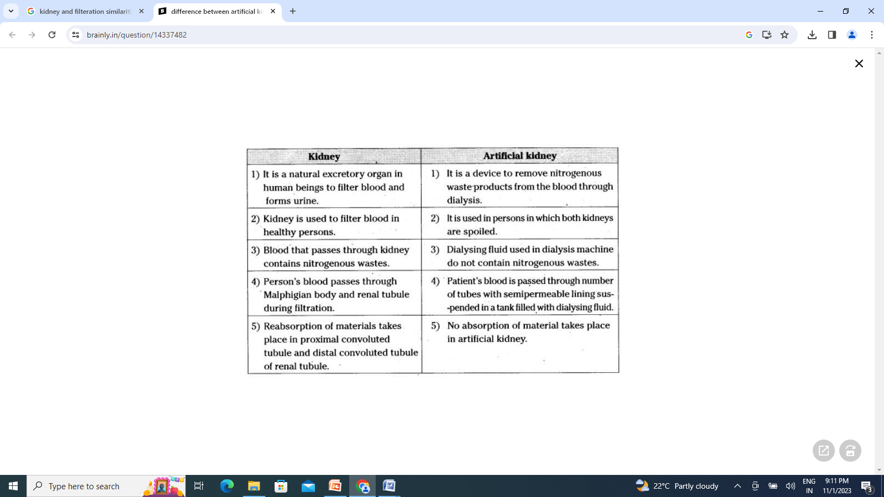

Thermoregulation of the Human Body

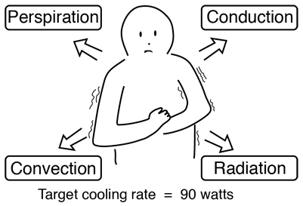 | The human body has the remarkable capacity for regulating its core temperature somewhere between 98°F and 100°F (36.6⁰C to 37.7⁰C) when the ambient temperature is between approximately 68°F and 130°F (20.0⁰C to 54.4⁰C) according to Guyton (This presumes a nude body and dry air).

The external heat transfer mechanisms are radiation, conduction, convection and evaporation of perspiration. The process is far more than the passive operation of these heat transfer mechanisms, however. The body takes a very active role in temperature regulation. The temperature of the body is regulated by neural feedback mechanisms which operate primarily through the hypothalmus. The hypothalmus contains not only the control mechanisms, but also the key temperature sensors. Under control of these mechanisms, sweating begins almost precisely at a skin temperature of 37°C and increases rapidly as the skin temperature rises above this value. The heat production of the body under these conditions remains almost constant as the skin temperature rises.

If the skin temperature drops below 37°C a variety of responses are initiated to conserve the heat in the body and to increase heat production. These include
- Vasoconstriction to decrease the flow of heat to the skin.
- Cessation of sweating.
- Shivering to increase heat production in the muscles.
- Secretion of norepinephrine, epinephrine, and thyroxine to increase heat production
- In lower animals, the erection of the hairs and fur to increase insulation.

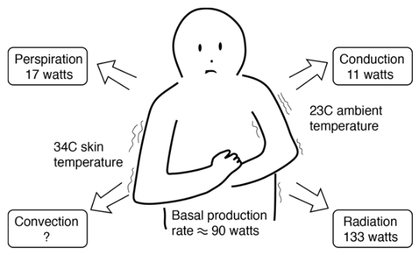
Cooling of the Human Body
This is a simplified model of the process by which the human body gives off heat. Even when inactive, an adult male must lose heat at a rate of about 90 watts as a result of his basal metabolism. One implication of the model is that radiation is the most important heat transfer mechanism at ordinary room temperatures. This model indicates that an unclothed person at rest in a room temperature of 23⁰C or 73 Fahrenheit would be uncomfortably cool. Select one of the cooling mechanisms for further details about how the model numbers were obtained. The skin temperature of 34⁰C is a typical skin temperature taken from physiology texts, compared to the normal core body temperature of 37⁰C.
Even when inactive, an adult male must lose heat at a rate of about 90 watts as a result of his basal metabolism. This becomes a problem when the ambient temperature is above body temperature, because all three standard heat transfer mechanisms work against this heat loss by transferring heat into the body. Our ability to exist in such conditions comes from the efficiency of cooling by the evaporation of perspiration.
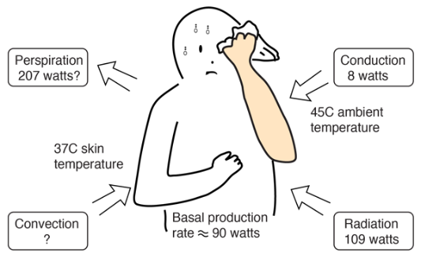
At a temperature of 113 Fahrenheit (45⁰C) the evaporation process must overcome the transfer of heat into the body and give off enough heat to accomplish a 90 watt net outward flowrate of energy. Because of the body's temperature regulatory mechanisms, the skin temperature would be expected to rise to 37°C at which point perspiration is initiated and increases until the evaporation cooling is sufficient to hold the skin at 37°C if possible. With those assumptions about the temperatures, the Stefan-Boltzman law for an area of 2 m² and emissivity 0.97 gives a net input power of 109 watts to the body. The perspiration cooling must overcome that and produce the net outflow of 90 watts for equilibrium.
The transfer of heat is normally from a high temperature object to a lower temperature object. Heat transfer changes the internal energy of both systems involved according to the Ist law of Thermodynamics.
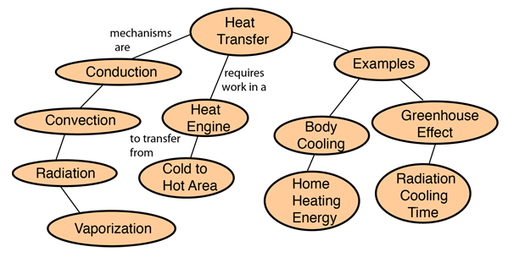

Heat Conduction
Conduction is heat transfer by means of molecular agitation within a material without any motion of the material as a whole. If one end of a metal rod is at a higher temperature, then energy will be transferred down the rod toward the colder end because the higher speed particles will collide with the slower ones with a net transfer of energy to the slower ones. For heat transfer between two plane surfaces, such as heat loss through the wall of a house, the rate of conduction heat transfer is:
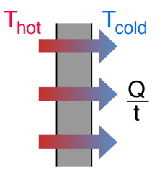
  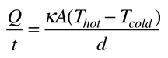
  = heat transferred in time =
  = thermal conductivity of the barrier
   | area
  = temperature
  = thickness of barrier

Stefan-Boltzmann Law
The thermal energy radiated by a blackbody radiator per second per unit area is proportional to the fourth power of the absolute temperature and is given by
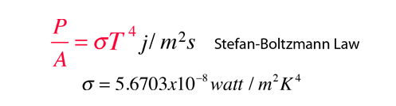
For hot objects other than ideal radiators, the law is expressed in the form:

where e is the emissivity of the object (e = 1 for ideal radiator). If the hot object is radiating energy to its cooler surroundings at temperature T_{c}, the net radiation loss rate takes the form

The Stefan-Boltzmann relationship is also related to the energy density in the radiation in a given volume of space.

Heat Radiation
Thermal radiation is energy transfer by the emission of electromagnetic waves which carry energy away from the emitting object. For ordinary temperatures (less than red hot"), the radiation is in the infrared region of the electromagnetic spectrum. The relationship governing the net radiation from hot objects is called the Stefan-Boltzmann law:
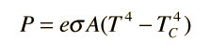
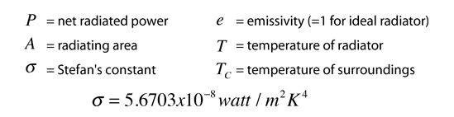
While the typical situation envisioned here is the radiation from a hot object to its cooler surroundings, the Stefan-Boltzmann law is not limited to that case. If the surroundings are at a higher temperature (T_{C} > T) then you will obtain a negative answer, implying net radiative transfer to the object.

Heat Convection
Convection is heat transfer by mass motion of a fluid such as air or water when the heated fluid is caused to move away from the source of heat, carrying energy with it. Convection above a hot surface occurs because hot air expands, becomes less dense, and rises. Hot water is likewise less dense than cold water and rises, causing convection currents which transport energy.
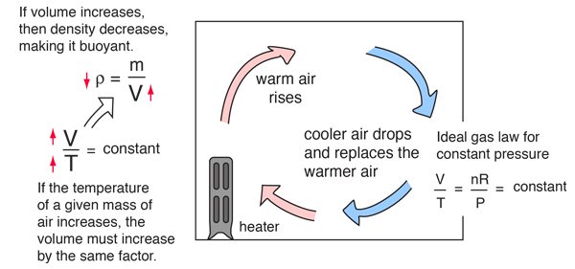
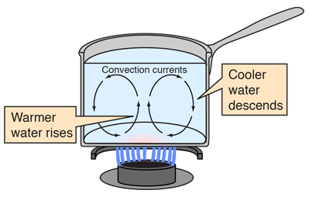 | Convection can also lead to circulation in a liquid, as in the heating of a pot of water over a flame. Heated water expands and becomes more buoyant. Cooler, more dense water near the surface descends and patterns of circulation can be formed, though they will not be as regular as suggested in the drawing.

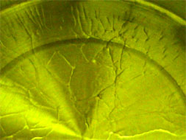 | Convection cells are visible in the heated cooking oil in the pot at left. Heating the oil produces changes in the index of refraction of the oil, making the cell boundaries visible. Circulation patterns form, and presumably the wall-like structures visible are the boundaries between the circulation patterns.

Convection is thought to play a major role in transporting energy from the center of the Sun to the surface, and in movements of the hot magma beneath the surface of the earth. The visible surface of the Sun (the photosphere) has a granular appearance with a typical dimension of a granule being 1000 kilometers. The image at right is from the NASA Solar Physics website and is credited to G. Scharmer and the Swedish Vacuum Solar Telescope. The granules are described as convection cells which transport heat from the interior of the Sun to the surface. | 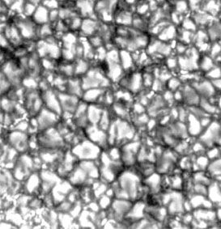
In ordinary heat transfer on the Earth, it is difficult to quantify the effects of convection since it inherently depends upon small nonuniformities in an otherwise fairly homogeneous medium. In modeling things like the cooling of the human body, we usually just lump it in with conduction.

Perspiration Cooling of Body
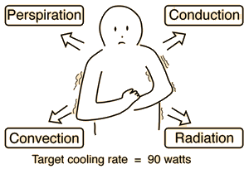  For 600 gm/day perspiration,  cooling rate Q/t = 17 watts. | When the ambient temperature is above body temperature, then radiation, conduction and convection all transfer heat into the body rather than out. Since there must be a net outward heat transfer, the only mechanisms left under those conditions are the evaporation of perspiration from the skin and the evaporative cooling from exhaled moisture. Even when one is unaware of perspiration, physiology texts quote an amount of about 600 grams per day of "insensate loss" of moisture from the skin.  The cooling effect of perspiration evaporation makes use of the very large heat of vaporization of water. This heat of vaporization is 540 calories/gm at the boiling point, but is even larger, 580 cal/gm, at the normal skin temperature.
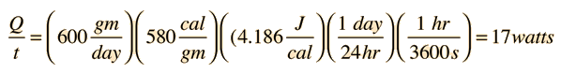
Top of Form
Top of Form
Bottom of Form
As part of the physiological regulation of body temperature, the skin will begin to sweat almost precisely at 37°C and the perspiration will increase rapidly with increasing skin temperature. Guyton reports that a normal maximum perspiration rate is about 1.5 liters/hour, but that after 4 to 6 weeks of acclimatization in a tropical climate, it can reach 3.5 liters/hr! You would have to just sit around drinking constantly, just to keep from getting dehydrated! That maximum rate corresponds to a maximum cooling power of almost 2.4 kilowatts!
Bottom of Form
ELECTRICAL SIGNALLING IN BIOLOGY

It is well known that electrical signals are deeply associated with living entities. Much of our understanding of excitable tissues is derived from studies of specialized cells of neurons or myocytes. However, electric potential is present in all cell types and results from the differential partitioning of ions across membranes. This electrical potential correlates with cell behavior and tissue organization. In recent years, there has been exciting, and broadly unexpected, evidence linking the regulation of development to bioelectric signals. However, experimental modulation of electrical potential can have multifaceted and pleiotropic effects, which makes dissecting the role of electrical signals in development difficult. Here, I review evidence that bioelectric cues play defined instructional roles in orchestrating development and regeneration, and further outline key areas in which to refine our understanding of this signaling mechanism.

Source: NIH: National Library of Medicines (https://www.ncbi.nlm.nih.gov/pmc/articles/PMC8180260/#:~:text=Electrical%20states%20are%20transferable%20signals,1B).

Electric eels are probably the best known electrogenic animals. Electrogenic animals can generate their own electricity. There are also animals that can detect electricity. They are called electroreceptive.
Most electrogenic animals are also electroreceptive. But there are many electroreceptive animals that are not electrogenic. Some electroreceptive animals are echidnas, platypuses, bees, spiders, dolphins, sharks and rays. Some types of bacteria, yeast and fish are also electrogenic.

Electric Fish
Almost 350 species of fish can generate and detect electrical signals. Why so many fish? It can be very dark underwater. Fish can use electricity to communicate and move around in the dark. They can also use it to attack prey.

Scientists classify electric fish into two groups. Weakly electric and strongly electric.

Weakly Electric Fish: Weakly electric fish have electric organs in their tails. This structure can generate up to one volt of electricity. An AA battery generates 1.5 volts of electricity. The electric field produced by electric organs travels about 1 metre around the fish. Weakly electric fish also have special cells in their skin. Electroreceptor cells help the fish sense changes in its own electric field. The fish can sense the size, shape and location of objects through changes in its electric field. It can also sense if there are other, similar fish nearby. This ability is called electrolocation. Weakly electric fish don’t make enough electricity to attack prey. The elephantnose fish is an example of a weakly electric fish.

Strongly Electric Fish: Only a few types of fish are strongly electric. These include electric eels, electric catfishes and electric rays. The elephantnose fish only has one electric organ. But electric eels have three pairs of electric organs! Together these organs make up four-fifths of the eel’s body. Eels generate low-voltage pulses for electrolocation. But they generate high-voltage pulses for hunting and self-defence. These pulses can be up to 860 volts. Electric eels are the most powerful electric fish. Shocks from them can be deadly to humans.

How do these fish generate electricity?
The fish’s electric organ is filled with disc-shaped cells. These are called electrocytes. Electrocytes are positively charged on the outside. They are negatively charged on the inside.
But sometimes the fish sends a message from its brain. This signal travels through its nervous system to its electric organ. There, it changes the pattern of electrical charges in the cells. One side of each stack becomes positive. The other side becomes negative. This alternating pattern of charges creates an electrical current. This turns the electrocytes into a living battery! The signals reach the cells at exactly the same time. This turns stacks of electrocytes into a series of batteries. This increases their total voltage.

So why don’t these fish zap themselves?
Scientists aren’t really sure why. It may be that the current leaves their bodies too quickly to hurt them. It may be that fish’s electric organs are far away from its other organs. Scientists also think electric fish may have proteins around their electric organs. These could act as insulators.

In 1800, the explorer Alexander von Humboldt witnessed a swarm of electric eels leap out of the water eto defend themselves against oncoming horses. Most people thought the story so unusual that Humboldt made it up.
Electric eels But fish using electricity is more common than you might think and yes, electric eels are a type of fish. Underwater, where light is scarce, electrical signals offer ways to communicate,
navigate, and find—plus, in rare cases, stun—prey.
Nearly 350 species of fish have specialized anatomical structures that generate and detect electrical signals.These fish are divided into two groups, depending on how much electricity they produce. Electric organs Scientists call the first group the weakly electric fish. Structures near their tails called electric organs produce up to a volt of electricity, about two-thirds as much as a AA battery.

How does this work? The fish's brain sends a signal through its nervous system to the electric organ, which is filled with stacks of hundreds or thousands of disc-shaped cells called electrocytes. Normally, electrocytes pump out sodium and potassium ions to maintain a positive charge outside and negative charge inside. But when the nerve signal arrives at the electrocyte,
it prompts the ion gates to open. Positively charged ions flow back in. Now, one face of the electrocyte is negatively charged outside and positively charged inside. But the far side has the opposite charge pattern. These alternating charges can drive a current, turning the electrocyte into a biological battery. The key to these fish's powers is that nerve signals are coordinated to arrive at each cell at exactly the same time. That makes the stacks of electrocytes act like thousands of batteries in series. The tiny charges from each one add up to an electrical field that can travel several meters.

Electro receptors Cells are buried in the skin allow the fish to constantly sense this field and the changes to it caused by the surroundings or other fish. The Peter’s elephantnose fish, for example, has an elongated chin called a schnauzenorgan that's riddled in electroreceptors. That allows it to intercept signals from other fish, judge distances, detect the shape and size of nearby objects, and even determine whether a buried insect is dead or alive. But the elephantnose and other weakly electric fish don't produce enough electricity to attack their prey. That ability belongs to the strongly electric fish, of which there are only a handful of species. Electric eel The most powerful strongly electric fish is the electric knife fish, more commonly known as the electric eel. Three electric organs span almost its entire two-meter body.
Like the weakly electric fish, the electric eel uses its signals to navigate and communicate, but it reserves its strongest electric discharges for hunting using a two-phased attack that susses out and then incapacitates its prey. First, it emits two or three strong pulses, as much as 600 volts. These stimulate the prey's muscles, sending it into spasms and generating waves that reveal its hiding place. Then, a volley of fast, high-voltage discharges causes even more intense muscle contractions. The electric eel can also curl up so that the electric fields generated at each end of the electric organ overlap. The electrical storm eventually exhausts and immobilizes the prey, and the electric eel can swallow its meal alive. Electric catfish The other two strongly electric fish are the electric catfish, which can unleash 350 volts with an electric organ that occupies most of its torso, and the electric ray, with kidney-shaped electric organs on either side of its head that produce as much as 220 volts.

There is one mystery in the world of electric fish: why don't they electrocute themselves? It may be that the size of strongly electric fish allows them to withstand their own shocks, or that the current passes out of their bodies too quickly. Some scientists think that special proteins may shield the electric organs, but the truth is, this is one mystery science still hasn't illuminated.

Unit IV: Concepts in Bioengineering
Biomechanics: Mechanical properties of tissues, Prosthesis and rehabilitation
Bioprinting: 3D printing of biological tissues and organs
Biomaterials: Types, properties and applications
Tissue Engineering: Principle, Components, Scafold synthesis

BIOMECHANICS

Mechanical properties of tissues:

Prosthesis and Rehabilitation:

Prosthesis: A prosthesis is a device designed to replace a missing part of the body or to make a part of the body work better. Diseased or missing eyes, arms, hands, legs, or joints are commonly replaced by prosthetic devices. False teeth are known as dental prostheses. An artificial replacement of the jaw bone is called a maxillofacial prosthesis.

There are many types of prosthetic devices to help people regain mobility. They fall into four main categories; transradial, transhumeral, transtibial, and transfemoral. Each serves a different function depending on what body part is missing.

3D BIOPRINTING

Bioprinting is an additive manufacturing process similar to 3D printing – it uses a digital file as a blueprint to print an object layer by layer. But unlike 3D printing, bioprinters print with cells and biomaterials, creating organ-like structures that let living cells multiply. Although bioprinting is a relatively new technology, it has huge potential to benefit industries like regenerative and personalized medicine, drug discovery and cosmetics. Find out how bioprinting works.

The three basic steps of bioprinting:
1. Pre-bioprinting. This involves creating a digital file for the printer to read. Today, these files are often based on CT and MRI scans. Researchers prepare cells and mix them with their bioink, using a live-cell imaging system to ensure there are enough cells to bioprint a tissue model successfully.
2. Bioprinting. Researchers load the cell-laden bioink into a cartridge and choose one or multiple printheads, depending on the structure they’re trying to build. Developing different types of tissue requires researchers to use different types of cells, bioinks and equipment.
3. Post-bioprinting. Most structures are crosslinked to become fully stable. Crosslinking is usually done by treating the construct with either ionic solution or UV light – the construct’s composition helps researchers determine what kind of crosslinking to use. Then the cell-filled constructs are placed inside an incubator for cultivation.

What are (some of) the applications?
Today’s bioprinting technologies are still new to many researchers. As scientists in the field continue making discoveries, bioprinting can have a huge impact on a range of application areas.
Drug development:
Many of today’s studies rely on living subjects – an inconvenient and expensive method for both academic and commercial organizations. Bioprinted tissues can be used instead during the early stages, providing a more ethical and cost-effective solution. Using bioprintined tissue can help researchers determine a drug candidate’s efficacy sooner, enabling them to save money and time.
Artificial organs:
The organ donation list is so long that patients wait years before getting the help they need. Being able to bioprint organs could help clinicians keep up with patients or eliminate the list entirely. While this solution is far down the line, it is one of the most impactful possibilities in the field.
Wound healing:
A lot of tissue-specific bioinks are available today, enabling researchers to work with artificial skin cells, neurons, hepatocytes and more. One day, clinicians could use these models for therapeutic procedures like skin grafts, bone bandages for combat wounds or even plastic surgery.
This is still a new and emerging field – biocompatible 3D printing was invented in the early 1980s, with cell-embedded bioprinting being invented in 2003 by Thomas Boland, and we’ve come a long way in a short time! As more researchers get access to the latest bioprinting technology, the innovating will only accelerate.

BIOMATERIALS
From medical implants to artificial limbs and the bandages that cover cuts, so many things have been designed from a special set of materials that work well with the human body. These biomaterials are vital to medicine, healthcare, and the world as we know it. It takes special effort to design things that work directly with the human body.

Technically, we could try and use any material as a biomaterial, but to be successful, it needs to be compatible with the biological system it’s interacting with. All the materials we’ve talked about (metals, ceramics, polymers, and composites – and even living cells and tissues) can be candidates for biomaterials, as long as they have the right skills for the job.

That is where biocompatibility comes in. it is a general term for how compatible a material is with living tissue. It is not only an important feature of biomaterials, it’s what makes something a biomaterial. There are four main ways a material can interact with biological organization: it can hurt; it can dissolve and be replaced by cells; body can surround it with a protective layer; or it can bond with the living tissue.

Biocompatible materials are the ones that result in healthy bodily responses. They don’t tend to cause blood clots or infections, and lead to normal, uncomplicated healing. Which can be really important, because for most applications, your biomaterials will at least partly come in contact with bodily tissues or cells, and often for long periods of time. Months. Years. Maybe decades. Over the years, the materials we consider biocompatible have changed a lot – from the animal tissue used by ancient Egyptians to stitch wounds, to the wood used in olden-day peg legs, to the carefully-engineered materials we use today. Some of the more prominent ones today are titanium and stainless steel, used everywhere from joint replacements to dental implants.

Alloys- There’s also polyurethane, a type of polymer used in catheters, artificial heart valves, and other flexible devices, and hydrogels, for things like contact lenses. Each type has different properties that make it useful as a biomaterial. We’ve already talked about one use for alloys, like titanium and stainless steel, for example: braces. Titanium and some other alloys can be classified as biologically inert materials, which means they cause little or no reaction with nearby tissues. Your body may recognize them as foreign materials and try to surround them in fibrous tissue, but it doesn’t outright reject them. In the US alone, over four million people wear braces, many of whom have the metal kind. And that’s not counting all the people who have already spent a couple of years of their lives with alloys digging into their gums. You’ll also find these alloys in plenty of other things that we put in people’s bodies for an extended period of time. Titanium is often used in place of stainless steel because it lacks things like nickel that can sometimes cause allergic reactions. It also has a lower density compared to other metallic biomaterials, so a titanium implant will be lighter than a similar one made from stainless steel. And when it comes to artificial body parts, “lighter” usually translates to “much more comfortable.” But both titanium and stainless steel have excellent mechanical properties like strength, resistance to bending, and durability. That’s why they’re used for things that tend to get a lot of wear and tear, like teeth and joints.
Titanium is also often used to surround things that wouldn’t be biocompatible otherwise – a pacemaker, for example. On their own, having a battery and electrical circuits inside you wouldn’t be great. Surround them with a biocompatible material like titanium, though, and it becomes much safer. Sometimes, you can change the surface of a material to do even better than just not causing harm. For example, sometimes implanted devices that come into direct contact with blood, like pacemakers, cause dangerous blood clots or narrowing of blood vessels as the person’s body tries to heal around them.But scientists have found that coating the titanium in a mixture of collagen proteins and a blood thinner called heparin could someday help prevent those complications.

Polyurethane: The research is still in the early stages, but the fibrous tissues that form around implants are often collagen-based, so coating the titanium in the same proteins might speed up healing. Meanwhile, the blood thinner might prevent clots. Other types of titanium coatings are already used for surgeries where you need to get an implant to bond with the surrounding bone. Some knee replacements, for example, are coated with things like proteins and silver, which give the alloy the ability to bond with living tissue and discourage bacterial growth.
With things like knee replacements, that can be really important, because for the surgery to be successful, you typically need to get the implant to bond with the surrounding bone.
So when it comes to biocompatibility, alloys like titanium are super useful.
And with some clever engineering, you can make them even better.
Sometimes, though, you need a material that’s a little more flexible, like for a heart valve.
And for that, engineers often turn to polyurethane.
Like other polymers, polyurethane is made up of long, repeating chains arranged into larger molecules.
But the smaller segments of the polymer alternate between hard and soft, which gives it a super useful set of properties.
Polyurethane has a high level of elasticity, so it’s pretty flexible, but it’s also durable and resistant to tearing.
Combine these properties and you end up with a biomaterial that performs well under both static and dynamic loads.
More importantly, though, those hard and soft segments make polyurethane biocompatible.
In the 1980s, researchers discovered that the molecules in the softer segments helped make the polymer more blood-friendly because the platelet cells that cause clots didn’t stick to them as much.
Since then, engineers have worked to make polyurethanes with even better biocompatibility by changing the chemical structure of the hard segments so they don’t accumulate platelets as much, either.
But polyurethane isn’t the only polymer that’s widely-used as a biomaterial.
Hydrogels
There are also hydrogels, materials made up of things called hydrophilic structures, cross-linked polymers capable of holding large amounts of water.
Think of the polymers we’ve talked about before, with those long chemical chains,
but now they’re linked repeatedly between the chains, forming a network-like structure.
That network can then swell with water to fill in the gaps between the chains, leading to some interesting properties.
For example, one of the most widely used hydrogels is something called PHEMA, a material that’s pretty unreactive and supportive of biological processes.
It’s tough and doesn't degrade easily, isn’t absorbed by the body, and it can take on many different shapes and forms, making it the sort of swiss army knife of biomaterials.
These characteristics are what make PHEMA hydrogels so well-suited for contact lenses.
There’s even research on using them to deliver medicine to the eye!
In fact, the unique chemical structure of hydrogels in general could make them ideal for delivering drugs across the body.
Say you swallow a hydrogel capsule filled with medication that you might normally take in a shot.
When the pill enters your body, the water inside you will try to fill it up.
The hydrogel will take in the fluid and swell up to maintain its equilibrium, effectively pushing out the drug into your body and releasing it where it needs to go.
And if you use a hydrogel that your body can gradually absorb, it will just dissolve after it’s done its job.
The potential for future hydrogel applications is vast, including wound-healing bioadhesives,
Applications
artificial skin and cartilage, sexual organ reconstruction, and even vocal cord replacements.
So far, we’ve mostly talked about building devices to put in the body.
But biomaterials can be used to help boost the body’s existing behaviors, too.
For example, some researchers are working on a gel that can that can stick to your bodily tissues and help heal them faster.
This gel can help prevent internal blisters and infections by filling the dead space that’s created by surgeries like tumor removals.
After your body has the time to heal, the gel degrades and is absorbed.
On a much smaller scale – like, the size of individual cells –
researchers are also looking into biomaterials that could deliver things like DNA directly into cells they otherwise couldn’t get into.
By creating biomaterials that mimic viruses, you can trick cells into taking in these molecules, like some kind of cellular Trojan horse.
We might even be able to use them for cancer vaccines!
But like anything else in science, and especially medicine,
there are certain protocols biomaterial engineers are expected to follow to make sure what they’re designing is more than just effective – it has to be safe.
For example, early research might include testing the material on cells outside of the body, to get an idea of how biocompatible it is without risking anyone’s life.
Other times, it might involve animal testing, to see how a material affects the physiology of other animals before trying it on humans.
But the proper precautions aren’t always taken,
and there have been some cases where devices that were said to be safe caused reactions as mild as a rash or as serious as death.
Dalton Shield
Like the Dalkon Shield, an early IUD contraceptive.
When it was introduced in the late 1960s, the Dalkon Corporation marketed the Shield as superior to other IUDs on the market.
They said it had a lower failure rate, at about 1%, and that it was easier and less painful to insert and remove.
And then people started getting infections.
Which was weird, because the uterus is normally sterile.
By 1974, it had caused problems in tens of thousands of people, including at least 18 deaths.
Later investigations revealed that the culprit was the tail string attached to the IUD to help remove it.
The string was made of a bundle of thin nylon fibers with a shell of nylon around them,
and it acted like a wick, drawing bacteria up into the uterus.
Turns out, the parent company that bought Dalkon had known about this problem the whole time.
When one of their quality control employees insisted they address it, the company fired him instead – something that would be illegal in the US today.
On top of that, there were so many flaws in the human safety trial for the IUDs that it would take me another ten minutes just to list them all.
We’ll discuss the ethics of engineering in more detail in a later episode,
but what happened with the Dalkon Shield was a clear violation of even the most basic safety protocols.
They released a product they knew could be dangerous, didn’t tell anyone about the risk, and hoped for the best.
That plan didn’t work out well for anyone.
Biomaterials can be an incredibly powerful tool for improving people’s lives.
But as engineers, it’s up to us to wield that power responsibly.
So today we learned all about biomaterials.
We talked about alloys like titanium and their coatings, the special chemistry of polyurethane, and the cross-linked structure of hydrogels.
We also looked at ways to use biomaterials to boost the body’s existing behaviors, as well as their enormous future potential.
Finally, we talked about the importance of safety research.
I’ll see you next time, when we’ll shift directions a bit and learn about process control.
Crash Course Engineering is produced in association with PBS Digital Studios.
If you want to keep learning new things, check out It’s Okay to be Smart,
which is all about our curious universe and the science that makes it possible, hosted by Joe Hanson.
Check out It's Okay to be Smart and subscribe at the link below.
Crash Course is a Complexly production and this episode was filmed in the Doctor Cheryl C. Kinney Studio with the help of these wonderful people.
And our amazing graphics team is Thought Cafe.

Tissue Engineering

Tissue engineering is the use of a combination of cells, engineering and materials methods, and suitable biochemical and physio-chemical factors to improve or replace biological functions. In practice the term is closely associated with applications that repair or replace portions of or whole tissues (i.e., bone, cartilage, blood vessels, bladder, etc.). The term regenerative medicine is often used synonymously with tissue engineering, although those involved in regenerative medicine place more emphasis on the use of stem cells to produce tissues.

Stem cells are cells found in most, if not all, multi- cellular organism. They are characterized by the ability to renew themselves through mitotic cell division and differentiating into a diverse range of specialized cell types. The two broad types of mammalian stem cells are: embryonic stem cells that are isolated from the inner cell mass of blastocysts, and adult stem cells that are found in adult tissues.
Stem cells can now be grown and transformed into specialized cells with characteristics consistent with cells of various tissues such as muscles or nerves through cell culture. Highly plastic adult stem cells from a variety of sources, including umbilical cord blood and bone marrow, are routinely used in medical therapies. Embryonic cell lines and autologous embryonic stem cells generated through therapeutic cloning have also been proposed as promising candidates for future therapies.

Powerful developments in the multidisciplinary field of tissue engineering have yielded a novel set of tissue replacement parts and implementation strategies. Scientific advances in biomaterials, stem cells, growth and differentiation factors, and biomimetic environments have created unique opportunities to fabricate tissues in the laboratory from combinations of engineered extracellular matrices ("scaffolds"), cells, and biologically active molecules. Among the major challenges now facing tissue engineering is the need for more complex functionality, as well as both functional and biomechanical stability in laboratory-grown tissues destined for transplantation. The continued success of tissue engineering, and the eventual development of true human replacement parts, will grow from the convergence of engineering and basic research advances in tissue, matrix, growth factor, stem cell, and developmental biology, as well as materials science and bioinformatics.

In 2003, a report entitled "The Emergence of Tissue Engineering as a Research Field" has been published, which gives a thorough description of the history of this field.
Examples
- Bioartificial liver device — several research efforts have produced hepatic assist devices utilizing living hepatocytes.
- Artificial pancreas — research involves using islet cells to produce and regulate insulin, particularly in cases of diabetes.
- Artificial bladders — Anthony Atala (Wake Forest University) has successfully implanted artificially grown bladders into seven out of approximately 20 human test subjects as part of a long-term experiment.
- Cartilage — lab-grown tissue was successfully used to repair knee cartilage.
- Doris Taylor's heart in a jar
- Tissue-engineered airway
- Artificial skin constructed from human skin cells embedded in collagen
- Artificial bone marrow

Cells as building blocks
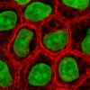  Stained cells in culture | Tissue engineering utilizes living cells as engineering materials. Examples include using living fibroblasts in skin replacement or repair, cartilage repaired with living chondrocytes, or other types of cells used in other ways. Cells became available as engineering materials when scientists discovered how to extend telomeres in 1998, producing immortalized cell lines. Before this, laboratory cultures of healthy, noncancerous mammalian cells would only divide a fixed number of times, up to the Hayflick limit.

Extraction
From fluid tissues such as blood, cells are extracted by bulk methods, usually centrifugation or apheresis. From solid tissues, extraction is more difficult. Usually the tissue is minced, and then digested with the enzymes trypsin or collagenase to remove the extracellular matrix that holds the cells. After that, the cells are free floating, and extracted using centrifugation or apheresis. Digestion with trypsin is very dependent on temperature. Higher temperatures digest the matrix faster, but create more damage. Collagenase is less temperature dependent, and damages fewer cells, but takes longer and is a more expensive reagent.

Types of cells
Cells are often categorized by their source:
- Autologous cells are obtained from the same individual to which they will be reimplanted. The distiguishing features of Autologous cells are:
  - They have the very few problems with rejection and pathogen transmission however in some cases might not be available. For example in genetic disease suitable autologous cells are not available. Also very ill or elderly persons, as well as patients suffering from severe burns, may not have sufficient quantities of autologous cells to establish useful cell lines. Moreover since this category of cells needs to be harvested from the patient, there are also some concerns related to the necessity of performing such surgical operations that might lead to donor site infection or chronic pain. Autologous cells also must be cultured from samples before they can be used: this takes time, so autologous solutions may not be very quick. Recently there has been a trend towards the use of mesenchymal stem cells from bone marrow and fat.
  - These cells can differentiate into a variety of tissue types, including bone, cartilage, fat, and nerve.
  - A large number of cells can be easily and quickly isolated from fat, thus opening the potential for large numbers of cells to be quickly and easily obtained. Several companies have been founded to capitalize on this technology, the most successful at this time being Cytori Therapeutics.
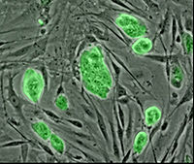
Mouse embryonic stem cells
- Allogenic cells come from the body of a donor of the same species. While there are some ethical constraints to the use of human cells for in vitro studies, the employment of dermal fibroblasts from human foreskin has been demonstrated to be immunologically safe and thus a viable choice for tissue engineering of skin.
- Xenogenic cells are these isolated from individuals of another species. In particular animal cells have been used quite extensively in experiments aimed at the construction of cardiovascular implants.
- Syngenic or isogenic cells are isolated from genetically identical organisms, such as twins, clones, or highly inbred research animal models.

Primary cells are from an organism.
Secondary cells are from a cell bank.

Stem cells are undifferentiated cells with the ability to divide in culture and give rise to different forms of specialized cells. According to their source stem cells are divided into "adult" and "embryonic" stem cells, the first class being multipotent and the latter mostly pluripotent; some cells are totipotent, in the earliest stages of the embryo. While there is still a large ethical debate related with the use of embryonic stem cells, it is thought that stem cells may be useful for the repair of diseased or damaged tissues, or may be used to grow new organs.

Scaffolds/Extracellular matrices
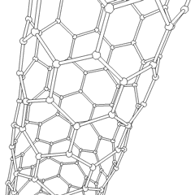 | Cells are often implanted or 'seeded' into an artificial structure capable of supporting three-dimensional tissue formation. These structures, typically called scaffolds, are often critical, both ex vivo as well as in vivo, to recapitulating the in vivo milieu and allowing cells to influence their own microenvironments. The purposes served by the scaffolds are:  - Allow cell attachment and migration  - Deliver and retain cells and biochemical factors  - Enable diffusion of vital cell nutrients and expressed products  - Exert certain mechanical and biological influences to modify the behaviour of the cell phase

This rotating Carbon nanotube shows its 3D structure. Carbon nanotubes are
- Among the numerous candidates for tissue engineering scaffolds
- They are biocompatible
- Resistant to biodegradation
- Can be functionalized with biomolecules.
- However, the possibility of toxicity with non-biodegradable nano-materials is not fully understood.
Also the requirements of an ideal scaffold are:
- A high porosity and an adequate pore size are necessary to facilitate cell seeding and diffusion throughout the whole structure of both cells and nutrients.
- Biodegradability is often an essential factor since scaffolds should preferably be absorbed by the surrounding tissues without the necessity of a surgical removal.
- The rate at which degradation occurs has to coincide as much as possible with the rate of tissue formation: this means that while cells are fabricating their own natural matrix structure around themselves, the scaffold is able to provide structural integrity within the body and eventually it will break down leaving the neotissue, newly formed tissue which will take over the mechanical load.
- Injectability is also important for clinical uses.

Materials: They are usually functionally customized and the ideal properties are:

injectability,

synthetic manufacture

biocompatibility

non-immunogenicity

transparency

nano-scale fibers

low concentration

desired resorption rates

The different types of materials:
- Natural or constructed from natural materials - different derivatives of the extracellular matrix. Proteic materials, such as collagen or fibrin, and polysaccharidic materials, like chitosan or glycosaminoglycans (GAGs), are all suitable in terms of cell compatibility, but some issues with potential immunogenicity still remains. Among GAGs hyaluronic acid, possibly in combination with cross linking agents (e.g. glutaraldehyde, water soluble carbodiimide, etc...), bioresorbable sutures like collagen
- Synthetic – PuraMatrix, PLA - polylactic acid. This is a polyester which degrades within the human body to form lactic acid, a naturally occurring chemical which is easily removed from the body; polyglycolic acid (PGA) and polycaprolactone (PCL): their degradation mechanism is similar to that of PLA, but slightly slower.
The materials can be biodegradable or non-biodegradable.

Synthesis
A number of different methods has been described in literature for preparing porous structures to be employed as tissue engineering scaffolds. Each of these techniques presents its own advantages, but none is devoid of drawbacks.

- Nanofiber Self-Assembly: Molecular self-assembly is the method to create biomaterials with properties similar in scale and chemistry to that of the natural in vivo extracellular matrix (ECM). The polymers are immerced in the hydrogels and assemble on their own thus known as self assembly. These are hydrogel scaffolds, superior in vivo toxicology and biocompatibility.
- Textile technologies: these techniques include the preparation of non-woven meshes of different polymers. e.g. non-woven polyglycolide structures. Such fibrous structures are useful to grow different types of cells. The drawbacks -difficulties of obtaining high porosity and regular pore size.
- Solvent Casting & Particulate Leaching (SCPL): the preparation of porous structures with regular porosity, but with a limited thickness.
1.the polymer is dissolved into a suitable organic solvent (e.g. polylactic acid could be dissolved into dichloromethane),
2.the solution is cast into a mold filled with porogen particles of inorganic salt like sodium chloride, crystals of saccharose, gelatin spheres or paraffin spheres. The size of the porogen particles and the polymer to porogen ratio is directly correlated to the amount of porosity of the final structure.
3. The solvent is allowed to fully evaporate,
4.the composite structure in the mold is immersed in a bath of a liquid suitable for dissolving the porogen. Once the porogen has been fully dissolved a porous structure is obtained.
The drawback of SCPL - its use of organic solvents which must be fully removed to avoid any possible damage to the cells seeded on the scaffold.
- Gas Foaming: to overcome the necessity to use organic solvents and solid porogens a technique using gas as a porogen has been developed.
1.disc shaped structures made of the desired polymer are prepared by means of compression molding using a heated mold.
2.The discs are then placed in a chamber where are exposed to high pressure CO₂ for several days.
3.The pressure inside the chamber is gradually restored to atmospheric levels. During this procedure the pores are formed by the carbon dioxide molecules that abandon the polymer, resulting in a sponge like structure.
The drawbacks: prohibits the incorporation of any temperature labile material into the polymer matrix; the pores do not form an interconnected structure.
- Emulsification/Freeze-drying: this technique does not require the use of a solid porogen like SCPL.
1. a synthetic polymer is dissolved into a suitable solvent (e.g. polylactic acid in dichloromethane),
2. water is added to the polymeric solution
3. the two liquids are mixed in order to obtain an emulsion.
4. the emulsion is cast into a mold
5. quickly frozen by means of immersion into liquid nitrogen.
6. The frozen emulsion is subsequently freeze-dried to remove the dispersed water and the solvent, thus leaving a solidified, porous polymeric structure.
Drawbacks -it still requires the use of solvents, pore size is relatively small and porosity is often irregular. )
- Thermally Induced Phase Separation (TIPS): similar to the previous technique, (this phase separation procedure requires the use of a solvent with a low melting point that is easy to sublime. For example dioxane could be used to dissolve polylactic acid, then phase separation is induced through the addition of a small quantity of water: a polymer-rich and a polymer-poor phase are formed. Following cooling below the solvent melting point and some days of vacuum-drying to sublime the solvent a porous scaffold is obtained.) Liquid-liquid phase separation presents the same drawbacks of emulsification/freeze-drying.
- CAD/CAM Technologies: since most of the above described approaches are limited when it comes to the control of porosity and pore size, computer assisted design and manufacturing techniques have been introduced to tissue engineering. First a three-dimensional structure is designed using CAD software, then the scaffold is realized by using ink-jet printing of polymer powders or through Fused Deposition Modeling of a polymer melt.

Assembly methods
One of the continuing, persistent problems with tissue engineering is mass transport limitations. Engineered tissues generally lack an initial blood supply, thus making it difficult for any implanted cells to obtain sufficient oxygen and nutrients to survive, and/or function properly.
Self-assembly may play an important role here, both from the perspective of encapsulating cells and proteins, as well as creating scaffolds on the right physical scale for engineered tissue constructs and cellular ingrowth.
It might be possible to print organs, or possibly entire organisms. A recent innovative method of construction uses an ink-jet mechanism to print precise layers of cells in a matrix of thermoreversable gel. Endothelial cells, the cells that line blood vessels, have been printed in a set of stacked rings. When incubated, these fused into a tube.

Tissue culture
In many cases, creation of functional tissues and biological structures in vitro requires extensive culturing to promote survival, growth and inducement of functionality. In general, the basic requirements of cells must be maintained in culture, which include oxygen, pH, humidity, temperature, nutrients and osmotic pressure maintenance.
Tissue engineered cultures also present additional problems in maintaining culture conditions. In standard cell culture, diffusion is often the sole means of nutrient and metabolite transport. However, as a culture becomes larger and more complex, such as the case with engineered organs and whole tissues, other mechanisms must be employed to maintain the culture.
Another issue with tissue culture is introducing the proper factors or stimuli required to induce functionality. In many cases, simple maintenance culture is not sufficient. Growth factors, hormones, specific metabolites or nutrients, chemical and physical stimuli are sometimes required. For example, certain cells respond to changes in oxygen tension as part of their normal development, such as chondrocytes, which must adapt to low oxygen conditions or hypoxia during skeletal development. Others, such as endothelial cells, respond to shear stress from fluid flow, which is encountered in blood vessels.
Basic principle of Tissue engineering is illustrated in the following figure. Cells can be isolated from the patient’s body, and expanded in a petridish in laboratory. Once we have enough number of cells, they can be seeded on a polymeric scaffold material, and cultured in vitro in a bioreactor or incubator. When the construct is matured enough, then it can be implanted in the area of defect in patient’s body.
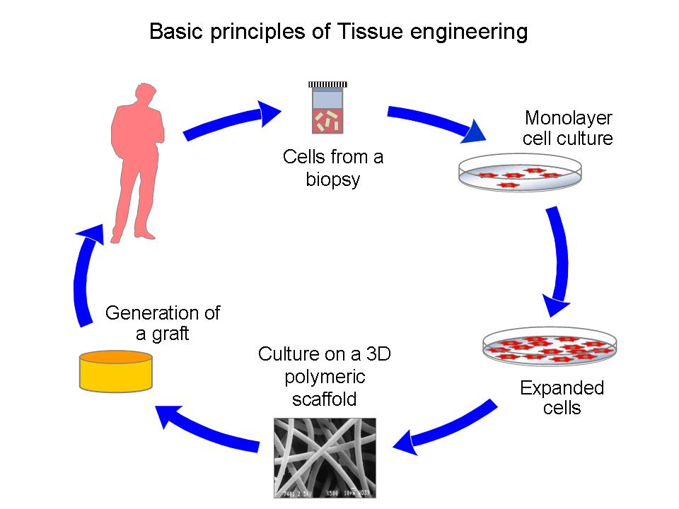

The application of the principles & methods of engineering & life sciences towards the fundamental understanding of structure, function & relationships in normal & pathological mammalian tissue & the development of biological substitutes to restore, maintain & improve tissue function.

… Symposium on Tissue Engineering (1988)

Defect Organ Function
Mechanical Cartilage Resist compression
Metabolites Liver Nitrogen metabolism
Synthetic Pancreas Insulin production
Communication Nerve Coordination
Combination Skin prevents water loss
immunologic barrier

UNIT V: APPLICATION AREAS OF BIOENGINEERING

Databases & Biocomputing: Acquisition, storage, processing and transmission of biological data and its applications like PCR
Bioinstrumentation: Diagnostic and Therapeutic devices
Bioimaging: Principle, types and examples,
Biosensors: Principle, types and examples,
Application of Artificial Intelligence in bio-medical field

Distributed Information Processing in Biological and Computational Systems

Biological systems, ranging from the molecular to the cellular to the organism level, are distributed and in most cases operate without central control. Such systems must solve information processing problems that are often very similar to problems faced by computational systems, including coordinated decision making, leader election, routing and navigation, and more. Over the last few years our ability to study and model biological systems has improved dramatically. Using advanced sequencing technologies we can now determine the composition of the genomes of hundreds of organisms. For specific cells and tissues we can query the set of active genes, their expression levels, and how their responses change in different conditions and over time. We can also determine which molecules within cells interact and how such interactions are wired to form the control diagram regulating cellular activity. Using this data we can build models of information processing within and between cells and answer questions regarding the methods biological systems use to achieve their goals that were out of reach even a few years ago. This data can also help us understand what computational problems are being solved by biological systems and how, which in turn can lead to specific algorithms that may also benefit computational systems.
Video: Distributed Information Processing in Biological and Computational Systems on Vimeo

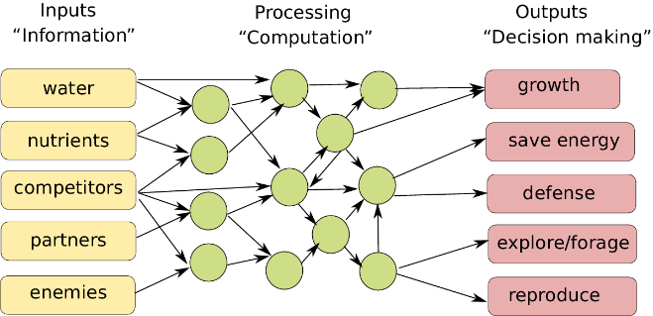 | Biological computing All biological organisms, be it primates, snails, plants or single-celled amoebas, sense their environment and internal state, and process, integrate and prioritise this information to compute which action to take next. Figure inspired on earlier work in Scheres and van der Putten  (Reference Scheres and van der Putten2017).

Defense system in Yeast: The robust defenses that yeast cells have evolved to protect themselves from environmental threats hold lessons that can be used to design computer networks and analyze how secure they are (Computer scientists at Carnegie Mellon University). Environmental “noise” is a key evolutionary pressure that shapes the interconnections within cells, as well as those of neural networks and bacterial/ecological networks. The researchers factored this into an established model for the evolution of molecular connections, resulting in an algorithm that gives rise to a rich range of architectures found in biological, computer and other types of networks.

It is said that this approach is particularly helpful in understanding how networks respond to cascading failures, whether it be an overloaded power grid or a computer network being overwhelmed by fake identities in a so-called sybil attack.

The generative model the CMU team developed can be used to tailor networks to the environments in which they are expected to operate. These strike a balance between highly connected networks that are efficient and fast but are prone to infections and cascading failures, such as the Internet and its large service providers, and more sparsely connected elements that are less efficient, requiring more time to relay information, but can better tolerate failures and attacks, such as peer to peer networks.

That’s a balance that evolution already has achieved in yeast. A yeast cell has about 6,000 genes, of which 20 percent are considered essential — that is, if the gene is removed, the cell dies. But Ziv Bar-Joseph, an associate professor in the Machine Learning Department and the Lane Center for Computational Biology, said that view of what is essential and what isn’t reflects how scientists study genes — by noting their effects on an organism when a gene is removed — not necessarily the gene’s importance.
“The cell did not evolve to protect itself against the deletion of these ‘essential’ genes,” Bar-Joseph said, noting that’s an event that doesn’t often occur in nature.
Rather, the fragility of genes, proteins and other cell components may reflect exposure to their environment. Those that lie near the cell surface, for instance, can expect to encounter lots of environmental stress, so the cell has evolved to tolerate the loss of some of them. Those involved in DNA duplication, on the other hand, normally don’t experience that kind of exposure to noise and so don’t have the same robust interconnections. That’s why the cell dies if one of those genes is removed, Bar-Joseph noted.
Just as biologists study genes by knocking them out, one by one, computer scientists often evaluate network security by removing a server and seeing how the network responds. But Navlakha said that’s not always realistic; many attacks or failures of computer and electrical networks can involve the loss of multiple, neighboring nodes.
To better understand the significance of how various networks are interconnected, the Carnegie Mellon researchers, including Christos Faloutsos, professor of computer science, and Xin He, a Lane Fellow in computational biology, modified the well-known duplication-divergence model used to explain the evolution of molecular networks. The concept is that gene duplication can result in two equivalent proteins that, over time, diverge to develop specialized subtasks, while also maintaining common connections.
By adjusting the duplication-divergence model to account for the pressure of environmental noise, the researchers developed a method that can be used to generate or evaluate the interconnection, or topology, of networks that work in a variety of environments. A military network, for instance, might not worry about malevolent viruses and noise because access is restricted, while a wireless sensor network deployed over a wide area might need to tolerate continual losses of random nodes.
At the same time, the evolutionary role of external noise might well prove to be an insight that will enhance the understanding of biological networks, Bar-Joseph added.

A comparative approach for the investigation of biological information processing: an examination of the structure and function of computer hard drives and DNA
Background: The robust storage, updating and utilization of information are necessary for the maintenance and perpetuation of dynamic systems. These systems can exist as constructs of metal-oxide semiconductors and silicon, as in a digital computer, or in the "wetware" of organic compounds, proteins and nucleic acids that make up biological organisms. We propose that there are essential functional properties of centralized information-processing systems; for digital computers these properties reside in the computer's hard drive, and for eukaryotic cells they are manifest in the DNA and associated structures.

Different spatial organisations of information processing in biological systems.  Left: centralised information processing based on a central dominant brain in primates  Middle: hybrid information processing in an octopus that combines a central brain with semi-autonomous information processing in its arms.  Right: fully distributed information processing with no central processing organ in plants | 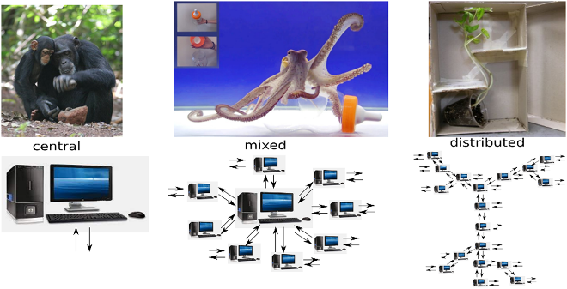

A descriptive framework is presented herein that compares DNA and its associated proteins and sub-nuclear structure with the structure and function of the computer hard drive. We can identify four essential properties of information for a centralized storage and processing system: (1) orthogonal uniqueness, (2) low level formatting, (3) high level formatting and (4) translation of stored to usable form. The corresponding aspects of the DNA complex and a computer hard drive are categorized using this classification. This is intended to demonstrate a functional equivalence between the components of the two systems, and thus the systems themselves.

Both the DNA complex and the computer hard drive contain components that fulfill the essential properties of a centralized information storage and processing system. The functional equivalence of these components provides insight into both the design process of engineered systems and the evolved solutions addressing similar system requirements. However, there are points where the comparison breaks down, particularly when there are externally imposed information-organizing structures on the computer hard drive.

A specific example of this is the imposition of the File Allocation Table (FAT) during high level formatting of the computer hard drive and the subsequent loading of an operating system (OS). Biological systems do not have an external source for a map of their stored information or for an operational instruction set; rather, they must contain an organizational template conserved within their intra-nuclear architecture that "manipulates" the laws of chemistry and physics into a highly robust instruction set. We propose that the epigenetic structure of the intra-nuclear environment and the non-coding RNA may play the roles of a Biological File Allocation Table (BFAT) and biological operating system (Bio-OS) in eukaryotic cells.

The comparison of functional and structural characteristics of the DNA complex and the computer hard drive leads to a new descriptive paradigm that identifies the DNA as a dynamic storage system of biological information. This system is embodied in an autonomous operating system that inductively follows organizational structures, data hierarchy and executable operations that are well understood in the computer science industry. Characterizing the "DNA hard drive" in this fashion can lead to insights arising from discrepancies in the descriptive framework, particularly with respect to positing the role of epigenetic processes in an information-processing context. Further expansions arising from this comparison include the view of cells as parallel computing machines and a new approach towards characterizing cellular control systems.

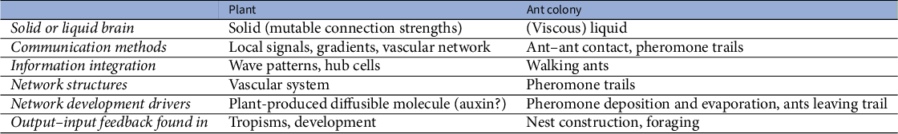

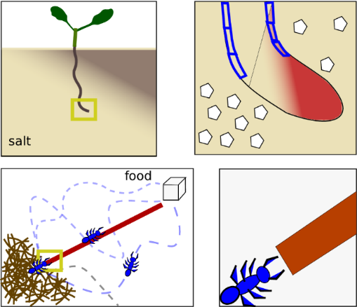 | Storage of spatial environmental information. Top: in the solid brain setting of a plant root, environmental information regarding the direction of a salt gradient can be stored internally in the shape of an auxin asymmetry. Bottom: in the liquid brain setting of an ant colony, environmental information regarding the direction and shortest path towards a food source is stored externally through a pheromone trail.

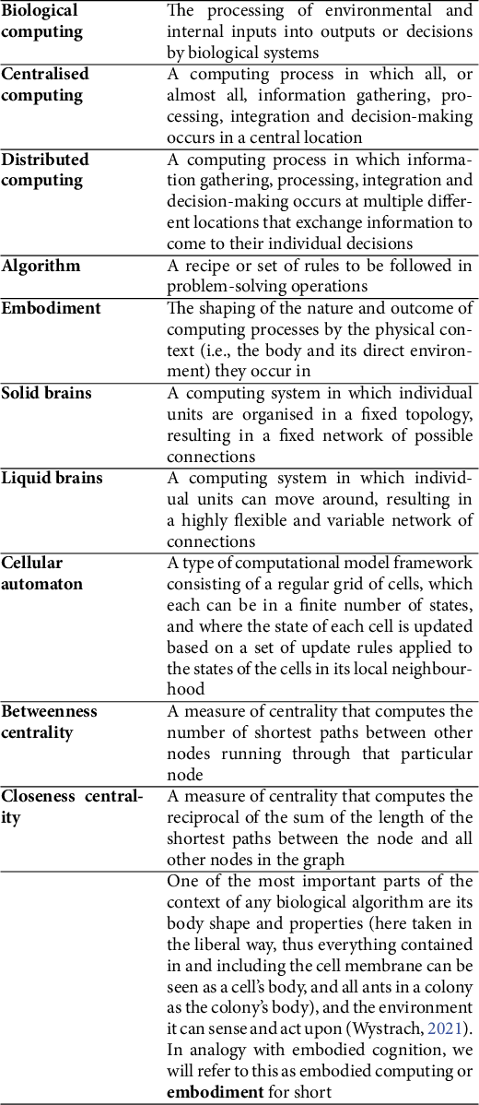
Source: A review article by Saket Navlakha, Ziv Bar-Joseph Communications of the ACM, January 2015, Vol. 58 No. 1, Pages 94-102

DNA Replication

DNA is capable of self reproduction. Parent DNA produces two daughter DNA molecules which are exact copies / replicas of parent DNA in N2 base sequence. Hence DNA duplication is called as DNA replication.
Definition-- It is making exact copies of parent DNA. It is bidirectional.

Steps of DNA Replication --

1)The first major step for the DNA Replication to take place is the breaking of hydrogen bonds between bases of the two antiparallel strands. The unwounding of the two strands is the starting point.

2)Activation of deoxyribonucleotides by energy & enzyme Phosphorylase.

3)Enzyme Endonuclease makes cut to one of the strands of DNA. The splitting happens in places of the chains which are rich in A-T. That is because there are only two bonds between Adenine and Thymine (there are three hydrogen bonds between Cytosine and Guanine). Helicase is the enzyme that splits the two strands. The initiation point where the splitting starts is called "origin of replication". The structure that is created is known as "Replication Fork”.

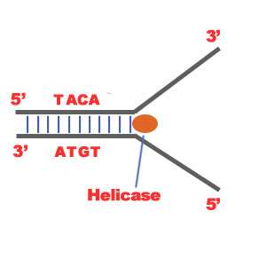
4)Topoisomerase, helix destabilizing protein stabilize replication fork.
5) Primase synthesizes RNA primer that attaches at 3’ end. RNA primer functions as 5’ end of new strand.
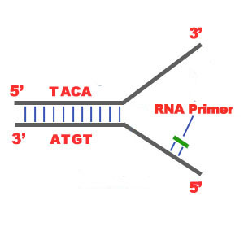
6) Two separated strands function as templates. Initiation of replication occurs at 3’ end.
7) DNA polymerase adds nucleotides in 5’ → 3’direction continuously complementary to the nucleotides of the template, e.g. A—T. This strand is called leading strand.
8) On the other strand DNA polymerase adds nucleotides in 5’ → 3’direction in short fragments. Hence it is called as lagging strand. The newly synthesized DNA fragments are called as Okazaki fragments. These fragments are joined by DNA ligase & become continuous.
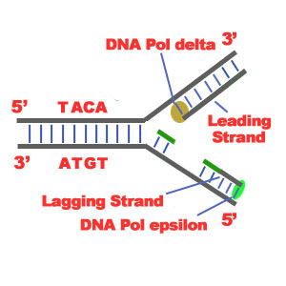

9) Once replication is completed, RNA primer is removed& DNA nucleotides are synthesized by DNA polymerase.

10) Proof reading – Mismatched N2 bases are removed by endonuclease & appropriate N2 bases are introduced by DNA polymerase.
11) In daughter DNA, 2 strands coil around each other to form helix.
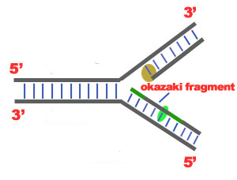
12) Thus in daughter DNA one strand is old i.e. conserved & another strand is new. Hence it is known as “semiconservative replication”.
Protein Synthesis:
Protein synthesis is the main mechanism in body with respect to growth and changes in the cell. It results in the production of amino acid chains which are for proteins (important component in body). But for short term reactions importance of protein synthesis is the production of variety enzymes for different reactions as needed by the body for that moment. Since we cannot exist without enzymes, protein synthesis is needed for our existence. The process of protein synthesis translates the codons (nucleotide triplets) of the messenger RNA (mRNA) into the 20-symbol code of amino acids that build the polypeptide chain of the proteins.
DNA mRNA PROTEIN is known as CENTRAL DOGMA in the process of protein synthesis. It has 2 steps – transcription (DNA mRNA) and translation (mRNA PROTEIN).
TRANSCRIPTION
The first step in protein synthesis is the transcription of mRNA from a DNA gene in the nucleus. In this phase, one strand of DNA double helix acts as a template to synthesize its complimentary strand i.e. mRNA. Transcription starts with an enzyme called polymerase copying the DNA sequence to a similar molecule called messenger RNA (mRNA). This synthesis takes place in a specific portion of DNA which is known as transcription bubble. In the bubble, DNA strands are separated or unzipped
The process of mRNA translation begins from its 5′-end towards its 3′-end as the polypeptide chain is synthesized from its amino-terminal (N-end) to its carboxyl-terminal (C-end). It replaces T with U (Uracil), a helper base, making it clear that the mRNA is a copy. The bases (A, T, G, C) on one strand of the DNA specify the order of bases on the new strand of mRNA (A, U, G, C). At the end of transcription, DNA stays inside the nucleus while the RNAs migrate from the nucleus into the cytoplasm.
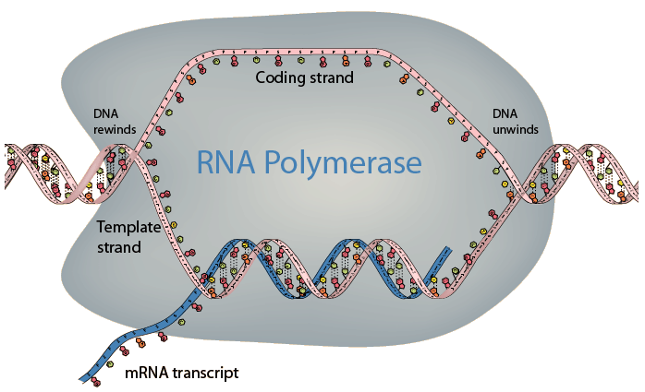
TRANSLATION
This is the second phase of protein synthesis where the ribosomes in the cytoplasm use transfer RNA (tRNA) to attach to the mRNA and translate the bases into amino acids. tRNA molecules bring the specified amino acids that the ribosome links together to make a protein. Translation has four steps viz. Activation and charging, Initiation, Elongation and Termination
Before the actual translation, activation, which is not part of translation in technical sense, occurs. In this step, the correct amino acid (AA) is joined to the correct t RNA. It is required for translation to proceed. When the activated tRNA has an amino acid linked to it, it is termed as "charged". The AA is joined by its carboxyl group to the 3' OH of the tRNA by an ester bond.

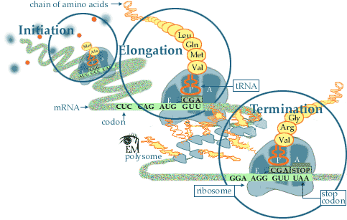

Initiation: In the cytoplasm, protein synthesis is actually initiated by the AUG codon on mRNA. The AUG codon signals both the interaction of the ribosome with m-RNA and also the tRNA with the anticodons (UAC). The tRNA which initiates the protein synthesis has N-formyl-methionine attached. The formyl group is really formic acid converted to an amide using the -NH₂ group on methionine (left most graphic)
The next step is for a second tRNA to approach the mRNA (codon - CCG). This is the code for proline. The anticodon of the proline tRNA which reads this is GGC. The final process is to start growing peptide chain by having amine of proline to bond to the carboxyl acid group of methinone (met) in order to elongate the peptide.
Elongation: Elongation of the peptide begins as various tRNA's read the next codon. In the example on the left the next tRNA to read the mRNA is tyrosine. When the correct match with the anticodons of a tRNA has been found, the tyrosine forms a peptide bond with the growing peptide chain. The proline is now hydrolyzed from the tRNA. The proline tRNA now moves away from the ribosome and back into the cytoplasm to reattach another proline amino acid.
Elongation and Termination: When the stop signal on mRNA is reached, the protein synthesis is terminated. The last amino acid is hydrolyzed from its t-RNA. The peptide chain leaves the ribosome. The N-formyl-methionine that was used to initiate the protein synthesis is also hydrolyzed from the completed peptide at this time.
The ribosome is now ready to repeat the synthesis several more times. The events following translation include post-translational modification and protein folding. During and after synthesis, polypeptide chains often fold to attain secondary, tertiary and quaternary structures. This process is known as maturation of protein and it takes place in Golgi Complex.

